AABInternational

GUIDE TO PREPARATION OF THE VISITING TEAM REPORT

#### FORM 209

The outline that follows is intended as a guide to preparation of the AABI Visiting Team Report. The completeness of the Report directly affects the ability of the Accreditation Committee and the Board of Trustees to arrive at sound accreditation decisions; therefore, this format should be adhered to and all topics should be covered with attention both to factual information and the quantitative and qualitative evaluation of that information. The narrative sections of the report should relate directly to the program strengths, weaknesses, suggestions or recommendations.

In each major section of the report, beginning with **Section II. Students,** and continuing through **Section XI. Continuous Assessment and Improvement**, report the team’s findings in the context of a brief narrative and close each section with these elements: Strengths, Weaknesses, Suggestions, and Recommendations. The visited institution must address recommendations; suggestions are considered informational. For the team to make a recommendation, the institution must be in **non-compliance** with an AABI criterion included within the context of a “MUST” statement in the Criteria Manual and/or Policies & Procedures (P&P) Manual, or program weaknesses that impact the overall viability of the program. For each recommendation, include the reference to the AABI Criteria and/or P&P Manuals, if appropriate. If it is a program weakness, AABI Forms 201 and/or 225 should be cited. (Example: UtopiaUniversity needs to move ahead aggressively to replace the current airport facilities and equipment [AABI 3.6.2]). Every effort should be made to be concise in reports, combining sections that are redundant and not restating material that is part of the Self-Study Report.

**Attachment 1**is a format/style guide for the Final Team Report, and sample Team Report Template. A full Team Report Template will be furnished to every team chair.

The following is an outline of possible topics to be included in the Visiting Team Report. Topics that are considered important or common to most reports are identified by **bold type,Arial font**.

**Cover Page** (all centered)

1. **AABI logo**
2. **Aviation Accreditation Board International**
3. **Final Report of the Accreditation Team’s Visit to**
4. **Name of college or university**
5. **Department or title of program(s) visited**
6. **City, State**
7. **Dates of visit**

Page 2 Intentionally left blank.

##### Page 3 (this page forward, left justified)

* 1. **Names and status of visiting team members (chair and educator/industry members), and members-in-training and observers, if any.**
  2. **Programs evaluated**
  3. **Organization of Report**

**I. Introduction** (page 4)

1. **Size, brief history, type (i.e., private, public, etc.) and purpose(s) of the institution.**
2. **How the institution is organized (e.g., into colleges, schools, etc.).**
3. **History, size, and purpose of the aviation unit.**
4. **Mission and objectives of the aviation unit and plans for attaining them.**
5. Any inappropriate objectives or any discrepancies between stated objectives and the team's impressions of what the actual objectives are. (Are they realistic? Are they attainable?)
6. **Goals and objectives: Do they reflect AABI criteria and outcomes?**
7. **Other information, which may be helpful in understanding the characteristics of the institution and aviation program.**
8. **For reaffirmation: Does the published and electronic literature of the institution accurately reflect the current AABI accreditation status of each program?**
9. **Does the program provide reliable information to the public on their performance, including student achievement?**
10. **Names and positions of persons interviewed.**
11. **List number of students and classes visited.**
12. **List names of students only for student leaders and those in attendance for Welcome Reception and/or other special events/meetings.**
13. **List documents reviewed.**

# **II. Students**

1. Students’ impressions of the program.
2. Student views of the aviation graduate's role in the aviation profession.
3. **Student recognition of the mission, goals and objectives of the academic unit.**
4. **Student attitudes and morale.**
5. **Availability of scholarships, student aid and employment for aviation students.**
6. **Student organizations and how active they are.**
7. **Student participation in honors programs, and course and faculty evaluations.**
8. **Student views of advising and counseling procedures.**
9. **Student quality in relation to other students on campus.**
10. **Size of class enrollments.**
11. **Admission, retention, and record-keeping policies in the aviation program. (Note any program/institution-wide policy discrepancies.)**
12. **Appropriate evidence evaluated by the visiting team.**

## III. Program Mission and Educational Goals

1. **The aviation unit’s mission and how it clearly complements the institutional mission.**
2. **The published program educational objectives, the process by which they are established and measured.**
3. **Specific processes and timelines for ongoing evaluation of educational objectives.**
4. **How assessment results are used to document successes and shortcomings, and to improve program effectiveness and address shortcomings.**

## IV. Student Learning Outcomes

1. **How the curriculum and curriculum process achieves program mission.**
2. **General outcomes and measurements relate to educational goals.**
3. **Program-level outcomes and measurements relate to educational goals.**
4. **Evidence (materials) reviewed by the visiting team demonstrated achievement of the general and program-specific outcomes.**

###### Curriculum

1. **Degree title and credit hours required.**
2. **Other degree programs administered by the aviation unit.**
3. **Course requirements in relation to AABI criteria in the six categories of the aviation core.**
4. **Thrust of the curriculum with respect to the program objectives stated in the Self-Study Report.**
5. **Required mathematics and science. (Are they appropriate and do they support technical courses in the program?)**
6. **Sequencing of courses and the appropriateness of prerequisites.**
7. **Course coverage. (Is course content broad enough to allow the student to continue growth and development?)**
8. Laboratory course components. (Are they well-coordinated with lecture components?)
9. Instructional techniques. (Are any unique or innovative techniques being used?)
10. Latitude of choice and arrangement of free electives.
11. Provision for accelerated study for those who have mastered areas of the program.
12. Provisions for problem-solving courses, seminars, and independent study to allow for differences in learning styles among students.
13. **Existence of outlines for all courses in a standard format. (Each outline should contain, at the minimum, course description, course objectives, topical outline with approximate percent of time spent on each topic, and instructional materials used such as a textbook.)**
14. **For baccalaureate programs, the inclusion of a significant upper division culminating experience.**
15. Specific processes and timelines are in place for ongoing evaluation of program educational objectives.
16. Assessment results are used to document successes and shortcomings, and to improve program effectiveness.
17. Plans are established to address shortcomings.

###### VI. Faculty

1. **The professional and academic qualifications of each faculty member.**
2. **Level of dedication, attitude toward students, and esprit-de-corps among faculty members.**
3. **Faculty's view of the:**
   1. **Administration's level of support;**
   2. **Administration's opinion of program;**
   3. **Administration's opinion of aviation graduates' role in industry;**
   4. **Degree of interaction between the aviation program administrator and faculty.**
4. **Faculty recognition of the mission, goals, and objectives of the academic unit.**
5. Adequacy of the teacher evaluation system.
6. Basis for instructional loads and their appropriateness.
7. Relationship between faculty qualifications and teaching areas assigned.
8. **Number of faculty and supporting staff; distribution of rank; faculty/student ratio.**
9. Policies on appointment, retention, promotion, tenure, etc. (Do formal policies exist and are they understood and accepted by the faculty?)
10. Opportunities for service, research, and publication.
11. **Faculty salary and benefit program and its adequacy in relation to faculty elsewhere in the institution and in comparable institutions in the region.**
12. **Whether, to what extent, and how successfully faculty is involved in consulting, professional association and society activities, writing for publication, research, and continuing education.**
13. Specific processes and timelines are in place for ongoing evaluation of educational objectives.
14. Assessment results are used to document successes and shortcomings, and to improve program effectiveness.
15. Plans are established to address shortcomings.

###### VII. Facilities, Equipment and Services

1. **Adequacy of campus and airport physical facilities in terms of space, lighting, temperature and humidity, maintenance, etc.**
2. Extent to which office space provides comfort for working and privacy for counseling.
3. Cooperation between the aviation program and areas offering supporting courses.
4. Availability of upper division courses to students in the supporting disciplines.
5. **Library holdings and location of holdings.**
6. Annual library appropriations available to the program and how they are spent.
7. **Use of library holdings and A/V materials by the faculty and students in the program.**
8. Cooperation between the aviation unit and institutional offices (e.g., counseling and testing, placement, admission, library, and other similar areas).
9. **Adequacy of computer lab facilities for students on campus and airport.**
10. **Aircraft and training device fleet evaluation in terms of adequate number and use, appearance, condition, state of the art equipment and a replacement plan for obsolescence.**
11. **Condition and current teaching value of all laboratory equipment for aircraft maintenance and avionics programs.**
12. **Existence of a comprehensive safety program/plan and adherence by all students/staff.**
13. Availability of adequate media equipment for classrooms.
14. Specific processes and timelines are in place for ongoing evaluation of educational objectives.
15. Assessment results are used to document successes and shortcomings, and to improve program effectiveness.
16. Plans are established to address shortcomings.

# **VIII. Institutional Structure and Support**

1. **Administration's view of the goals of the aviation program.**
2. **Aspirations of the administration regarding the aviation program.**
3. **Administration's plan for supporting the program commitment to aviation education. (Is it realistic?)**
4. Methods for establishing program priorities.
5. **Upper administration views regarding program status. (Is the program viewed as an identifiable academic unit on campus?)**
6. **Aviation program administration organization and its relationship to the administration of the parent institution.**
7. Opportunities for equal representation of faculty on faculty groups within the institution.
8. Rationale for allocation of funds within the college or school.
9. **Faculty recruitment procedures and criteria used for promotion within the college.**
10. **Budget analysis. (Is the budget based on stable funding and is it adequate?)**
11. Methods used for distributing travel funds among aviation faculty members.
12. How the program is evaluated and updated or modified when and where appropriate.
13. Faculty data: salaries; teaching loads; and policies regarding support of faculty growth and development.
14. **Involvement of faculty in the development of policies and procedures for achieving program objectives.**
15. **Faculty involvement in setting priorities in program planning.**
16. Aviation administrator's academic, professional and administrative qualifications.
17. Aviation administrator's responsibility and authority. (Are they commensurate?).

### IX. Aviation Safety Culture and Program

1. **Aviation safety program in documented form with designated responsibilities**
2. **Verified involvement of students, faculty and staff for flight, maintenance, avionics and laboratories.**
3. **Designation of appropriate safety committee and officer.**
4. Existence of a safety accident/incident reporting system that is utilized to improve safety.
5. Specific processes and timelines are in place for ongoing evaluation of educational objectives.
6. Assessment results are used to document successes and shortcomings, and to improve program effectiveness.
7. Plans are established to address shortcomings.

# **X. Relations with Industry**

1. Existence of a formal industry advisory committee. (If one does not exist, why not? If one does, evaluate its program objectives and its composition in terms of the backgrounds of its members.)
2. **Relationship between the aviation program and the practicing professionals in the industry. (How does industry support the program? How does the program support industry?)**
3. **Employer and alumni surveys. (Are they conducted on a regular basis to ascertain their views on the quality of the program? If not, why? Is so, evaluate the latest survey.)**
4. Information on current research performed and/or under way within the aviation unit.
5. Existence of a formal co-op and summer work experience program, and, if one exists, how it functions and its effectiveness as a program adjunct.
6. Specific processes and timelines are in place for ongoing evaluation of educational objectives.
7. Assessment results are used to document successes and shortcomings, and to improve program effectiveness.
8. Plans are established to address shortcomings.

**XI. Continuous Assessment and Improvement**

1. **Students:** Describe the specific process and timeline for ongoing evaluation of student admission, retention and graduation requirements, processes, rates, and placement.
2. P**rogram Mission and Educational Goals:** Describe the specific process and timeline for ongoing evaluation of educational goals:
3. **Student Learning Outcomes:** Describe the process and timeline for ongoing assessment of general, aviation core, program-level criteria and other outcomes.
4. **Curriculum:** Describe the process and timeline for ongoing assessment of the curriculum.
5. **Faculty and Staff:** Describe the process and timeline for ongoing assessment of all aspects related to faculty and staff.
6. **Facilities, Equipment and Services:** Describe the process and timeline for ongoing assessment of all aspects related to facilities, equipment and services.
7. **Institutional Structure and Support:** Describe the process and timeline for ongoing assessment of all aspects related to institutional structure and support.
8. **Aviation Safety Culture and Program:** Describe the process and timeline for ongoing assessment of all aspects related to the safety program and culture.
9. **Relations with Industry:** Describe the process and timeline for ongoing assessment of all relations with industry.

**XII. Summary of Strengths, Weaknesses, Suggestions and Recommendations**

Include a summary of all strengths, weaknesses, suggestions and recommendations reported throughout the report under each of the headings and numbered consecutively. This summary operates as a convenience to any entity reviewing the report.

**ATTACHMENT 1**

**TEAM REPORT**

**FORMAT/STYLE GUIDE**

The purpose of the Format/Style Guide is to assist team members and chairs in the development of the Final Report of the Accreditation Team’s Visit. The establishment of styles or formatting and instructions will provide a consistent appearance in all reports submitted to institutions. The attached “template” assigns styles and describes formatting commands to simplify the formatting process. The team report template will be sent to all team members prior to a visit to aid in development of the visiting team report.

**Fonts:**

**Arial, 14 pt., section headers all caps, centered.**

**Arial, 12 pt., subsection headers underlined, left justified.**

Times New Roman, 12 pt., all body text, single line spacing.

Section Strengths, Weaknesses, Suggestions and Recommendations Arial,12 pt., underlined, left justified.

**Track Changes:**

We recommend that the team use “Track Changes” during the report preparation and editing process.

Go to Tools and select “Track Changes.” Documents can also be compared and merged by going to Tools and selecting “Compare and Merge Documents.” (Thumbnails/screen grabs are included on the following page.)

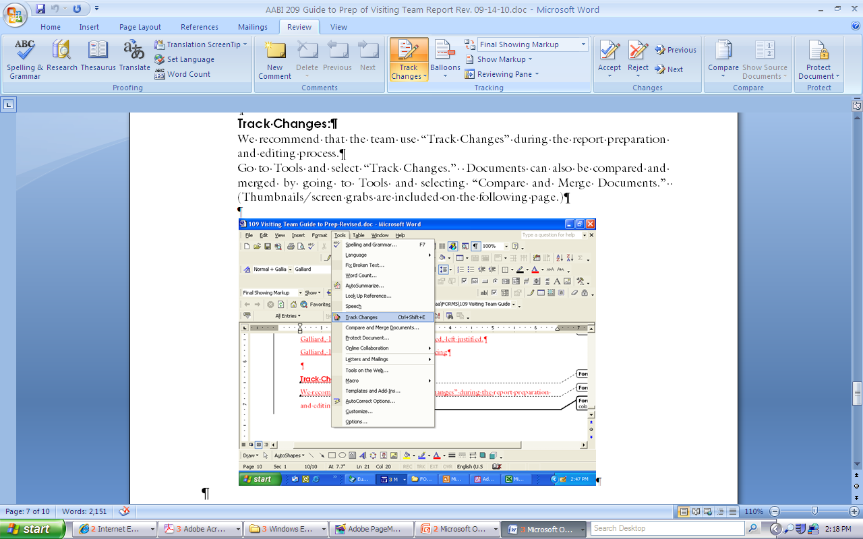

APPENDIX A

#### FORM 224 – TEAM REPORT FLOW CHART

